1/11/2022

Mobile Application Development

Lab-8 Manual

Safdar Hussain, BSCS-VII-A

CMS: 023-18-0059

Lab8

MainActivity.java

package com.example.myapplication;  
  
import androidx.appcompat.app.AppCompatActivity;  
  
import android.os.Bundle;  
import android.os.SystemClock;  
import android.view.View;  
import android.widget.Chronometer;  
  
public class MainActivity extends AppCompatActivity {  
 private Chronometer chronometer;  
 private boolean running;  
 @Override  
 protected void onCreate(Bundle savedInstanceState) {  
 super.onCreate(savedInstanceState);  
 setContentView(R.layout.*activity_main*);  
 chronometer = findViewById(R.id.*chron*);  
 }  
  
 public void Start(View view){  
 if(!running){  
 chronometer.start();  
 running=true;  
 }  
 }  
  
 public void Stop(View view){  
 if(running){  
 chronometer.stop();  
 running=false;  
 }  
 }  
  
 public void Reset(View view){  
 chronometer.setBase(SystemClock.*elapsedRealtime*());  
 chronometer.start();  
 running=true;  
 }  
  
}

activitymain.xml

*<?*xml version="1.0" encoding="utf-8"*?>*<androidx.constraintlayout.widget.ConstraintLayout xmlns:android="http://schemas.android.com/apk/res/android"  
 xmlns:app="http://schemas.android.com/apk/res-auto"  
 xmlns:tools="http://schemas.android.com/tools"  
 android:layout_width="match_parent"  
 android:layout_height="match_parent"  
 tools:context=".MainActivity">  
  
 <RelativeLayout  
 android:layout_width="match_parent"  
 android:layout_height="match_parent"  
 tools:layout_editor_absoluteX="-16dp"  
 tools:layout_editor_absoluteY="16dp">  
  
 <Chronometer  
 android:id="@+id/chron"  
 android:layout_width="289dp"  
 android:layout_height="251dp"  
 android:layout_above="@+id/button6"  
 android:layout_alignParentTop="true"  
 android:layout_alignParentEnd="true"  
 android:layout_alignParentRight="true"  
 android:layout_marginTop="173dp"  
 android:layout_marginEnd="76dp"  
 android:layout_marginRight="76dp"  
 android:layout_marginBottom="194dp"  
 android:gravity="center"  
 android:textSize="36sp" />  
  
 <Button  
 android:id="@+id/button5"  
 android:layout_width="110dp"  
 android:layout_height="62dp"  
 android:layout_alignParentEnd="true"  
 android:layout_alignParentRight="true"  
 android:layout_alignParentBottom="true"  
 android:layout_marginTop="0dp"  
 android:layout_marginEnd="230dp"  
 android:layout_marginRight="230dp"  
 android:layout_marginBottom="131dp"  
 android:onClick="Start"  
 android:text="Start" />  
  
 <Button  
 android:id="@+id/button6"  
 android:layout_width="wrap_content"  
 android:layout_height="64dp"  
 android:layout_alignParentEnd="true"  
 android:layout_alignParentRight="true"  
 android:layout_alignParentBottom="true"  
 android:layout_marginEnd="139dp"  
 android:layout_marginRight="139dp"  
 android:layout_marginBottom="130dp"  
 android:onClick="Stop"  
 android:text="Stop" />  
  
 <Button  
 android:id="@+id/button7"  
 android:layout_width="114dp"  
 android:layout_height="64dp"  
 android:layout_alignParentEnd="true"  
 android:layout_alignParentRight="true"  
 android:layout_alignParentBottom="true"  
 android:layout_marginEnd="24dp"  
 android:layout_marginRight="24dp"  
 android:layout_marginBottom="129dp"  
 android:onClick="Reset"  
 android:text="Reset" />  
 </RelativeLayout>  
</androidx.constraintlayout.widget.ConstraintLayout>

Output

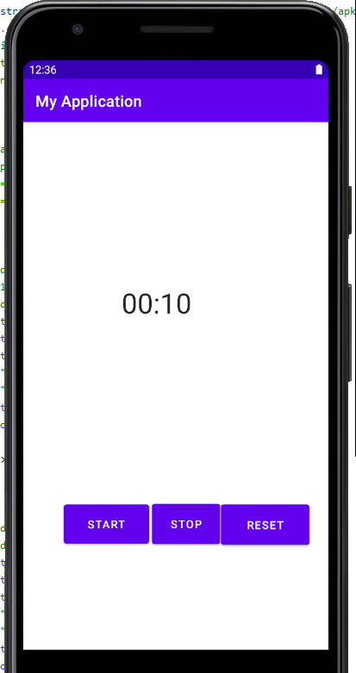

Activity 2:

MainActivity.java

package com.example.myapplication;  
  
import androidx.appcompat.app.AppCompatActivity;  
  
import android.os.Bundle;  
import android.view.View;  
import android.view.animation.Animation;  
import android.view.animation.AnimationUtils;  
import android.widget.Button;  
import android.widget.ImageView;  
  
public class MainActivity extends AppCompatActivity {  
 ImageView img;  
 Button toogleButton;  
 Thread thread;  
 @Override  
 protected void onCreate(Bundle savedInstanceState) {  
 super.onCreate(savedInstanceState);  
 setContentView(R.layout.*activity_main*);  
 img = findViewById(R.id.*imageView*);  
 toogleButton = findViewById(R.id.*button*);  
 thread = new Thread();  
 }  
  
 public void start(View view){  
 Animation move = (Animation) AnimationUtils.*loadAnimation*(getBaseContext(), R.anim.*rotate*);  
 img.startAnimation(move);  
 }  
}

activity_main.xml

*<?*xml version="1.0" encoding="utf-8"*?>*<androidx.constraintlayout.widget.ConstraintLayout xmlns:android="http://schemas.android.com/apk/res/android"  
 xmlns:app="http://schemas.android.com/apk/res-auto"  
 xmlns:tools="http://schemas.android.com/tools"  
 android:layout_width="match_parent"  
 android:layout_height="match_parent"  
 tools:context=".MainActivity">  
  
 <ImageView  
 android:id="@+id/imageView"  
 android:layout_width="173dp"  
 android:layout_height="153dp"  
 android:layout_marginTop="116dp"  
 app:layout_constraintEnd_toEndOf="parent"  
 app:layout_constraintStart_toStartOf="parent"  
 app:layout_constraintTop_toTopOf="parent"  
 app:srcCompat="@drawable/icon" />  
  
 <Button  
 android:id="@+id/button"  
 android:layout_width="wrap_content"  
 android:layout_height="wrap_content"  
 android:layout_marginTop="108dp"  
 android:onClick="start"  
 android:text="Rotate Button"  
 app:layout_constraintBottom_toBottomOf="parent"  
 app:layout_constraintEnd_toEndOf="parent"  
 app:layout_constraintHorizontal_bias="0.535"  
 app:layout_constraintStart_toStartOf="parent"  
 app:layout_constraintTop_toBottomOf="@+id/imageView"  
 app:layout_constraintVertical_bias="0.0" />  
</androidx.constraintlayout.widget.ConstraintLayout>

Rotation.xml

*<?*xml version="1.0" encoding="utf-8"*?>*<set xmlns:android="http://schemas.android.com/apk/res/android">  
 <rotate  
 android:fromDegrees="0"  
 android:toDegrees="360"  
 android:pivotX="25%"  
 android:pivotY="25%"  
 android:duration="5000" />  
</set>

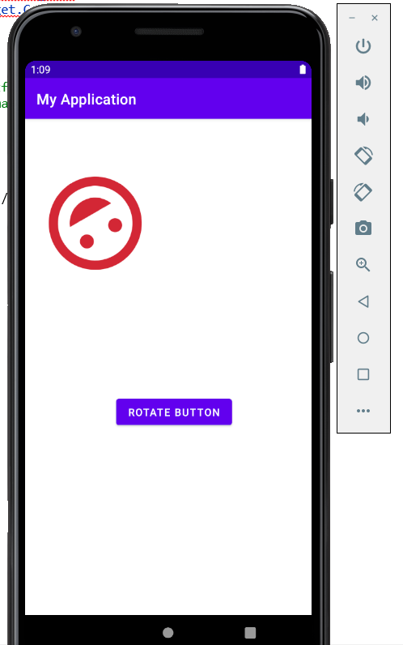

**Activity 3: Create a Media Player using Foreground Service**

**Create a mediaplayer using foreground service, which will constantly show the song being currently played in Notification bar.**

Main.java

package com.example.myapplication;

import androidx.appcompat.app.AppCompatActivity;

import android.os.Bundle;

public class MainActivity extends AppCompatActivity {

@Override

protected void onCreate(Bundle savedInstanceState) {

super.onCreate(savedInstanceState);

setContentView(R.layout.activity_main);

}

}

ForegroundService.java

package com.example.myapplication;

import android.annotation.SuppressLint;

import android.app.Notification;

import android.app.PendingIntent;

import android.app.Service;

import android.content.Intent;

import android.os.IBinder;

import android.widget.RemoteViews;

import androidx.annotation.NonNull;

import androidx.annotation.Nullable;

import androidx.core.app.NotificationChannelCompat;

import androidx.core.app.NotificationCompat;

import java.security.Provider;

import java.util.List;

import java.util.Map;

public class ForegroundService extends Service {

public static final String channel_id ="ForegroundServiceChannel";

public static final String channel_name ="ClickMusic";

@Override

public void onCreate(){super.onCreate();}

public int onStartCommand(Intent intent, int flags, int startId){

@SuppressLint("RemoteViewLayout") RemoteViews collapsedView = new RemoteViews(getPackageName(),

R.layout.notification_collapse);

@SuppressLint("RemoteViewLayout") RemoteViews expandedView = new RemoteViews(getPackageName(),

R.layout.notification_expended);

Intent clickIntent = new Intent(this,NotificationReceiver.class);

PendingIntent pendingIntent = PendingIntent.getBroadcast(this,

0,clickIntent,0);

collapsedView.setTextViewText(R.id.text_view_collapsed_1,"This is a message");

expandedView.setTextViewText(R.id.image_view_expanded,"This is a expanded message");

expandedView.setOnClickPendingIntent(R.id.image_view_expanded,pendingIntent);

Intent intent_recording = new Intent(this,NotificationReceiver.class);

PendingIntent pendingIntent_recording = PendingIntent.getBroadcast(this,

123,intent_recording,0);

String forInput = intent.getStringExtra("inputExtra");

createNotificationChannel();

Notification notification = new NotificationChannelCompat.Builder(this, channel_id)

.se

}

@Nullable

@Override

public IBinder onBind(Intent intent) {

return null;

}

}

NotificationReceiver.java

package com.example.myapplication;

import android.content.BroadcastReceiver;

import android.content.Context;

import android.content.Intent;

import android.util.Log;

import android.widget.Toast;

import androidx.core.app.NotificationCompat;

import androidx.core.app.NotificationManagerCompat;

public class NotificationReceiver extends BroadcastReceiver {

@Override

public void onReceive(Context context, Intent intent) {

Toast.makeText(context, "Image Clicked", Toast.LENGTH_SHORT).show();

NotificationManagerCompat notificationManagerCompat = NotificationManagerCompat.from(context);

notificationManagerCompat.cancel(1);

Log.d("REC","Begin Clcok");

}

}

**Activity 4: Create a simple alarm application, which will notify user at specific time**

Use the alarm manager to create an alarm service which will notify user on specific times

MainActivity.java

package com.example.myapplication;

import androidx.appcompat.app.AppCompatActivity;

import android.app.AlarmManager;

import android.app.PendingIntent;

import android.content.Intent;

import android.os.Bundle;

import android.view.View;

public class MainActivity extends AppCompatActivity {

@Override

protected void onCreate(Bundle savedInstanceState) {

super.onCreate(savedInstanceState);

setContentView(R.layout.activity_main);

}

public void onClick(View view){

AlarmManager alarmManager = (AlarmManager) getSystemService(ALARM_SERVICE);

Intent myReceiverIntent = new Intent(this,Receiver.class);

PendingIntent pendingIntent = PendingIntent.getBroadcast(this,1234,myReceiverIntent,0);

alarmManager.set(AlarmManager.RTC_WAKEUP,100,pendingIntent);

}

}

Receiver.java

package com.example.myapplication;

import android.app.Notification;

import android.app.NotificationChannel;

import android.app.NotificationManager;

import android.app.PendingIntent;

import android.content.BroadcastReceiver;

import android.content.Context;

import android.content.Intent;

import android.os.Build;

import android.widget.Toast;

import androidx.annotation.RequiresApi;

import androidx.core.app.NotificationCompat;

public class Receiver extends BroadcastReceiver {

String channel_id = "Android_Channel";

String channel_name = "Android_Channel_Name";

@RequiresApi(api = Build.VERSION_CODES.O)

@Override

public void onReceive(Context context, Intent intent) {

Toast.makeText(context, "Alarm is on", Toast.LENGTH_SHORT).show();

//Step 1: create a refeence of notification manager

NotificationManager nm = (NotificationManager) context.getSystemService(Context.NOTIFICATION_SERVICE);

//Step2: Create an intent

Intent intent1 = new Intent(context,MainActivity.class);

PendingIntent pendingIntent=PendingIntent.getActivity(context,0,intent1,0);

// Step 2,2: Creating action

NotificationCompat.Action action = new NotificationCompat.Action(R.drawable.ic_launcher_background,"OPEN",null);

//Step 2.3 Build Notification

NotificationCompat.Builder builder = new NotificationCompat.Builder(context,channel_id)

.setContentTitle("Test Notification")

.setContentText("This is notifcation")

.setAutoCancel(true)

.setSmallIcon(R.drawable.ic_launcher_background)

.setContentIntent(pendingIntent)

.addAction(action);

Notification notification = builder.build();

//Step 3:

NotificationChannel notificationChannel = new NotificationChannel(channel_id,channel_name,NotificationManager.IMPORTANCE_DEFAULT);

nm.createNotificationChannel(notificationChannel);

//Step 4: Publish Notification

nm.notify(12345,notification);

}

}